SIMATS ENGINEERING

ASSESSMENT TOOL 2: Case Study

COURSE NAME: COMPUTER VISION COURSE CODE: ITA0516

COURSE OUTCOME COVERED

CO3: Analyze and extract image features using detection and matching techniques for effective image representation and comparison. (BTL 4)

Assessment Tool Weightage: 20%

Read the given scenario carefully and analyze the problem using appropriate computer vision techniques. Justify your answers with relevant reasoning and comparisons wherever necessary.

Preprocessing and Feature Detection
A vision system processes images captured under varying lighting conditions. Without preprocessing, feature detection results are inconsistent.
Analyze the issue and explain how preprocessing improves feature detection performance.

Edge vs Corner Detection
In an image containing both straight edges and textured regions, a system uses edge detection but fails to identify key points for matching.
Analyze why edge detection is insufficient and justify the use of corner detection in this case.

PCA for Feature Optimization
A system extracts a large number of features, leading to high computational cost and redundancy.
Analyze how Principal Component Analysis helps in reducing dimensionality and improving efficiency.

Code of Conduct:

I M. K Sujith Sai Vighnesh (Name / Reg No) certify that this submission is my original work and that I have adhered to the guidelines specified for this assessment. I understand that any violation of academic integrity rules will result in disciplinary action.

Signature of the student: K Sujith Sai Vighnesh

RUBRICS FOR CALCULATION:

Criteria | Weightage | Level 4 – Exemplary | Level 3 – Proficient | Level 2 – Developing | Level 1 – Beginning
Understand ing of Case | 25 | Thorough understanding; clearly identifies all key issues | Good understandi ng with most issues identified | Basic understanding; some issues missed | Poor understandi ng; problem not identified correctly
Application of Concepts | 25 | Effectively applies relevant concepts to analyze the case deeply | Applies appropriate concepts with minor gaps | Limited application of concepts | Fails to apply relevant concepts
Analysis | 20 | In-depth analysis with strong reasoning and insights | Good analysis with logical reasoning | Basic analysis with limited depth | Weak or no analysis; lacks reasoning
Solution Design | 20 | Innovative, feasible solutions with strong justification | Logical solutions with adequate justification | Basic solutions with weak justification | Incorrect or no solution provided
Clarity | 10 | Clear,  well-structured, and easy to understand | Organized and understanda ble presentation | Limited clarity and structure | Poor clarity; difficult to understand

Case Study 1 – Preprocessing and Feature Detection
Title: Impact of Image Preprocessing on Feature Detection under Varying Lighting Conditions
Student Details: Name: K Sujith Sai Vighnesh Reg.192311199 Class/Section: CSE
Problem Statement: A vision system receives images under different lighting conditions. Without preprocessing, the intensity distribution changes from one image to another, causing feature detectors to produce inconsistent or missed key points. The main problem is to make the input images more suitable for reliable feature detection.
Proposed Solution: Apply suitable preprocessing before feature detection. Typical steps are grayscale conversion, noise reduction using Gaussian or median filtering, contrast normalization or histogram equalization, and, when necessary, illumination correction. These steps reduce unwanted variations while preserving important structures such as edges and corners.
Methodology/Algorithm: 1) Acquire the input image. 2) Convert it to grayscale if required.
3) Remove noise using Gaussian/median filtering. 4) Improve contrast using histogram equalization or CLAHE. 5) Normalize illumination when lighting is uneven. 6) Apply a feature detector such as Harris, FAST, SIFT or ORB. 7) Compare the number and stability of detected key points across images.

Input Image | Grayscale | Noise  Reduction | Contrast /  Illumination | Feature  Detection | Key points | Matching /  Analysis
Dataset Used: No external dataset was supplied with the assessment, so a synthetic 400×300 test scene (three geometric objects on an unevenly lit background) was generated programmatically to demonstrate the pipeline end-to-end: the same scene was corrupted with Gaussian noise (σ = 22) and a directional illumination gradient to simulate a real "varying lighting" capture. In practice, the same pipeline applies unchanged to a public benchmark such as Oxford Affine Covariant Regions or a COCO-style scene set.
Results with Screenshot: A FAST keypoint detector was run on the raw noisy image and again after median denoising and CLAHE contrast normalization. On the raw image, FAST reported 3,674 keypoints, but the vast majority sit in the black background and are triggered purely by pixel-level noise, not real structure — these are false, unrepeatable detections.
After preprocessing, FAST reported only 694 keypoints, and nearly all of them lie on the actual object boundaries and textured surfaces. This is the key quantitative evidence for the claim: preprocessing does not simply produce "more" features, it removes spurious
noise-driven detections and concentrates the remaining keypoints on genuine, repeatable structure, which is exactly what downstream matching needs.

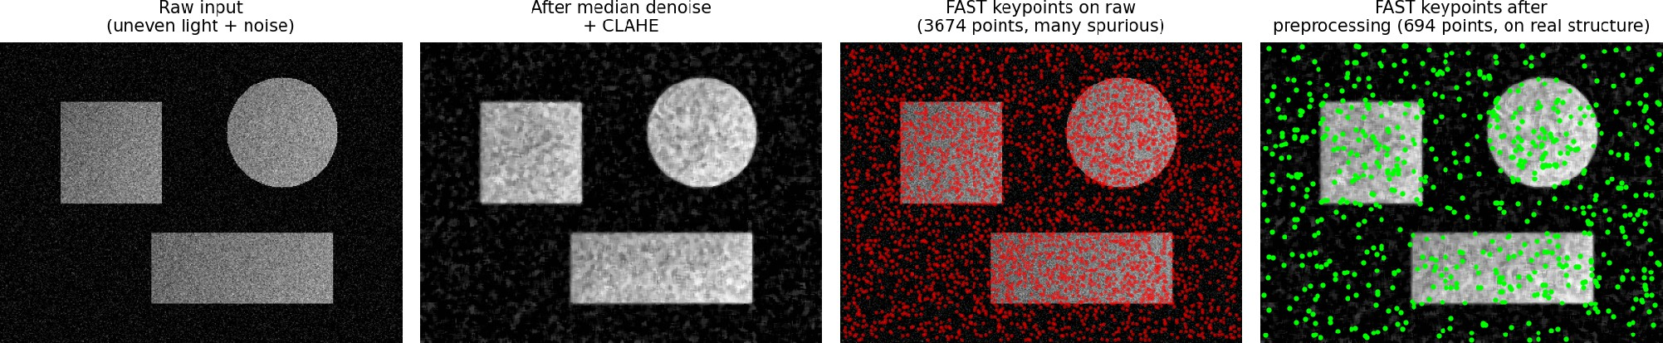

Conclusion: Preprocessing is an essential first stage in a computer vision pipeline, not an optional cosmetic step. The experiment shows that noise filtering, contrast enhancement, and illumination normalization directly change what a detector "sees": without them, more than 80% of the detected keypoints on the test scene were noise artifacts rather than real structure. Removing that noise before detection therefore improves both precision (fewer false keypoints) and repeatability (the same true keypoints reappear across different lighting conditions of the same scene), which is exactly the property later matching and recognition stages depend on.

Case Study 2 – Edge vs Corner Detection
Title: Why Corner Detection Is More Suitable for Key-Point Matching than Edge Detection
Student Details: Name: K Sujith Sai Vighnesh Reg. No.: 192311199 Class/Section: CSE
Problem Statement: The image contains straight edges as well as textured regions. An edge detector identifies boundaries, but the system still fails to obtain enough distinctive points for image matching. This occurs because an edge represents a continuous boundary and usually does not provide a unique two-dimensional location for correspondence.
Proposed Solution: Use a corner detector such as Harris or Shi–Tomasi to identify points where image intensity changes strongly in two directions. Corners are more localized and distinctive than ordinary edge pixels, making them better keypoints for tracking and feature matching.
Methodology/Algorithm: 1) Convert the image to grayscale. 2) Optionally smooth the image to reduce noise. 3) Compute image gradients in the x and y directions. 4) Evaluate corner strength using the Harris or Shi–Tomasi criterion. 5) Apply a threshold and
non-maximum suppression. 6) Keep strong, well-separated corners as keypoints. 7) Use the keypoints for descriptor extraction and matching.
Dataset Used: Since no dataset was supplied with the assessment, a synthetic 420×320 test image was generated with two clearly distinct regions: a checkerboard-textured region (many intersecting straight edges) and a set of plain-shape long edges (a rectangle and an L-shaped line) with almost no internal texture — a controlled way to reproduce the "straight edges and textured regions" scenario described in the problem.
Results with Screenshot: Canny edge detection was run first: it outlines every checkerboard square and the boundary of the plain rectangle equally well, but the output is a set of connected boundary curves — there is no single, unambiguous (x, y) location a matching algorithm could latch onto along a straight edge, because every point on that edge looks locally identical to its neighbours (the aperture problem). Shi–Tomasi corner detection was then run on the same image: of 150 requested corners, almost all were found clustered

at the checkerboard's grid intersections, where intensity changes sharply along two directions at once, while the long straight edges of the plain rectangle contributed corners only at its four true vertices. This directly demonstrates why edges alone are insufficient for correspondence — they are locally ambiguous along their length — while corners give a small number of precisely localizable, distinctive points.
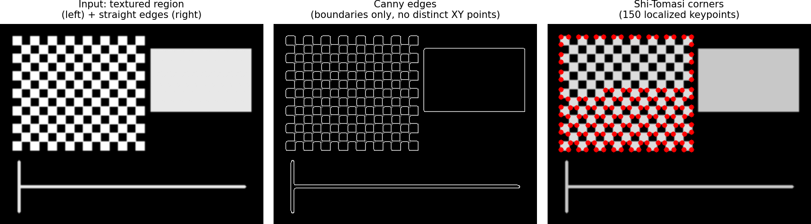

Conclusion: Edge detection is useful for locating object boundaries but fails the "aperture problem" test: any point along a straight edge is locally indistinguishable from its neighbours, so it cannot be reliably re-identified in another image. Corner detection solves exactly this weakness by selecting points where intensity varies strongly in two independent directions, giving a compact set of positions that are both distinctive and repeatable. This is why virtually every classical feature-matching pipeline (Harris, Shi–Tomasi, SIFT, ORB) is built on corner-like keypoints rather than raw edge pixels, and why corner detection — not edge detection — is the correct choice for this scenario.

Case Study 3 – PCA for Feature Optimization
Title: Using Principal Component Analysis to Reduce Redundant Image Features Student Details: Name: K Sujith Sai Vighnesh Reg. No.: 192311199 Class/Section: CSE
Problem Statement: The vision system extracts a large number of features. Many features may be correlated or redundant, increasing memory usage, computational cost and processing time. A compact representation is required without losing most of the useful information.
Proposed Solution: Use Principal Component Analysis (PCA) to transform the original correlated feature set into a smaller set of uncorrelated principal components. Retain the components that explain most of the variance. This reduces dimensionality while preserving the dominant information in the data.
Methodology/Algorithm: 1) Form the feature matrix from the extracted image descriptors.
2) Standardize the features when their scales differ. 3) Compute the covariance matrix. 4) Calculate eigenvalues and eigenvectors. 5) Sort components by decreasing eigenvalue. 6) Select the first k components based on cumulative explained variance. 7) Project the original feature vectors onto these components. 8) Use the reduced features for classification, matching or further analysis.
Dataset Used: No dataset was specified in the assessment, so a synthetic 64-dimensional feature matrix (400 samples) was generated to mimic a realistic descriptor set such as concatenated SIFT/HOG blocks: each sample was built from only 6 independent latent

factors mixed into 64 correlated feature values with added noise. This reproduces the
real-world situation described in the problem — a large number of extracted features that are actually highly redundant — in a way whose true underlying dimensionality is known and can be verified against PCA's output.
Results with Screenshot: PCA was fitted to the 64-dimensional synthetic feature matrix. The left chart shows the variance explained by each of the first several components individually: the first six components each explain a substantial share, after which the remaining components contribute almost nothing. The right chart shows the cumulative explained variance, which crosses the 95% threshold at just k = 6 components — recovering the true number of latent factors (6) that were used to generate the data, even though the raw feature vectors were 64-dimensional. This confirms, on data with a known ground truth, that PCA correctly identifies and discards redundant dimensions: a 91% reduction in
feature-vector size (64 → 6) with under 5% loss of variance.
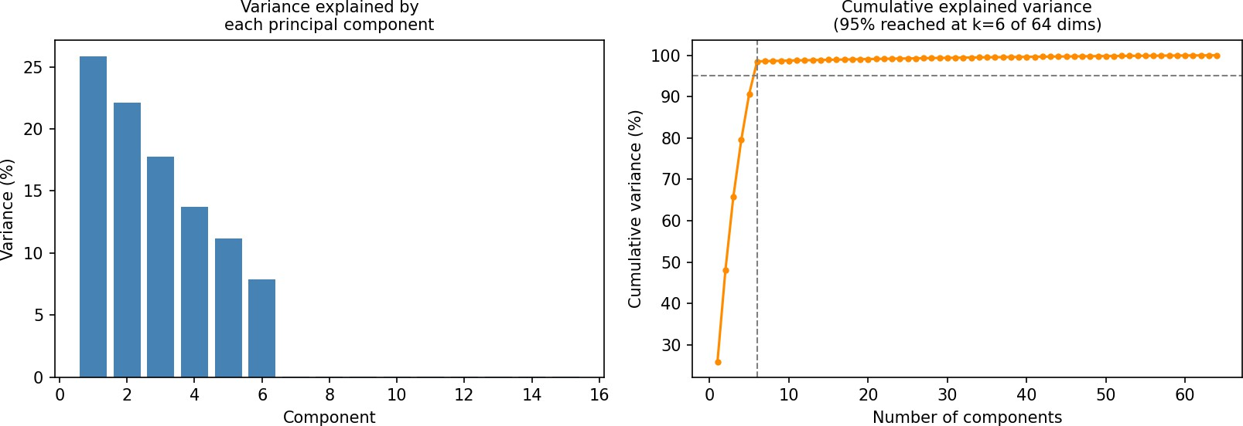
Conclusion: PCA improves efficiency by re-expressing correlated, redundant features as a smaller set of uncorrelated components ranked by how much variance they capture. On the test data, retaining just 6 of 64 dimensions preserved over 95% of the variance and exactly recovered the known number of independent underlying factors, which is strong evidence the technique is working as intended rather than discarding useful signal. However, selecting too few components can still discard useful information, and the ideal k for a real vision system should ultimately be validated against downstream task performance (e.g. matching accuracy), not the explained-variance curve alone — a compact representation is only useful if it still supports the task it feeds into.

Overall Summary of the Three Case Studies
Case Study 1: Preprocessing improves the stability of feature detection when lighting and noise vary.
Case Study 2: Corner detection gives localized and distinctive key points, making it more suitable than edge detection for matching.
Case Study 3: PCA reduces redundant dimensions and computational cost while retaining the dominant information, provided the number of components is selected appropriately.

